What is an Algorithm?
we will learn what algorithms are with the help of examples.
In computer programming terms, an algorithm is a set of well-defined instructions to solve a particular problem. It takes a set of input(s) and produces the desired output. For example,
An algorithm to add two numbers:
- Take two number inputs
- Add numbers using the + operator
- Display the result

Qualities of a Good Algorithm
- Input and output should be defined precisely.
- Each step in the algorithm should be clear and unambiguous.
- Algorithms should be most effective among many different ways to solve a problem.
- An algorithm shouldn't include computer code. Instead, the algorithm should be written in such a way that it can be used in different programming languages.

Algorithm Examples
Algorithm to add two numbers
Algorithm to find the largest among three numbers
Algorithm to find all the roots of the quadratic equation
Algorithm to find the factorial
Algorithm to check prime number
Algorithm of Fibonacci series

Algorithm 1: Add two numbers entered by the user
Step 1: Start
Step 2: Declare variables num1, num2 and sum.
Step 3: Read values num1 and num2.
Step 4: Add num1 and num2 and assign the result to sum.
sum←num1+num2
Step 5: Display sum
Step 6: Stop

Algorithm 2: Find the largest number among three numbers
Step 1: Start
Step 2: Declare variables a,b and c.
Step 3: Read variables a,b and c.
Step 4: If a > b
If a > c
Display a is the largest number.
Else
Display c is the largest number.
Else
If b > c
Display b is the largest number.
Else
Display c is the greatest number.
Step 5: Stop

Algorithm 3: Find Roots of a Quadratic Equation ax² + bx + c = 0
Step 1: Start
Step 2: Declare variables a, b, c, D, x1, x2, rp and ip;
Step 3: Calculate discriminant
D ← b2-4ac
Step 4: If D ≥ 0
r1 ← (-b+√D)/2a
r2 ← (-b-√D)/2a
Display r1 and r2 as roots.
Else
Calculate real part and imaginary part
rp ← -b/2a
ip ← √(-D)/2a
Display rp+j(ip) and rp-j(ip) as roots
Step 5: Stop

Algorithm 4: Find the factorial of a number
Step 1: Start
Step 2: Declare variables n, factorial and i.
Step 3: Initialize variables
factorial ← 1
i ← 1
Step 4: Read value of n
Step 5: Repeat the steps until i = n
5.1: factorial ← factorial*i
5.2: i ← i+1
Step 6: Display factorial
Step 7: Stop

Algorithm 5: Check whether a number is prime or not
Step 1: Start
Step 2: Declare variables n, i, flag.
Step 3: Initialize variables
flag ← 1
i ← 2
Step 4: Read n from the user.
Step 5: Repeat the steps until i=(n/2)
5.1 If remainder of n÷i equals 0
flag ← 0
Go to step 6
5.2 i ← i+1
Step 6: If flag = 0
Display n is not prime
else
Display n is prime
Step 7: Stop

Algorithm 6: Find the Fibonacci series till the term less than 1000
Step 1: Start
Step 2: Declare variables first_term,second_term and temp.
Step 3: Initialize variables first_term ← 0 second_term ← 1
Step 4: Display first_term and second_term
Step 5: Repeat the steps until second_term ≤ 1000
5.1: temp ← second_term
5.2: second_term ← second_term + first_term
5.3: first_term ← temp
5.4: Display second_term
Step 6: Stop

Data Structure and Types

What are Data Structures?
Data structure is a storage that is used to store and organize data. It is a way of arranging data on a computer so that it can be accessed and updated efficiently.
Depending on your requirement and project, it is important to choose the right data structure for your project. For example, if you want to store data sequentially in the memory, then you can go for the Array data structure.
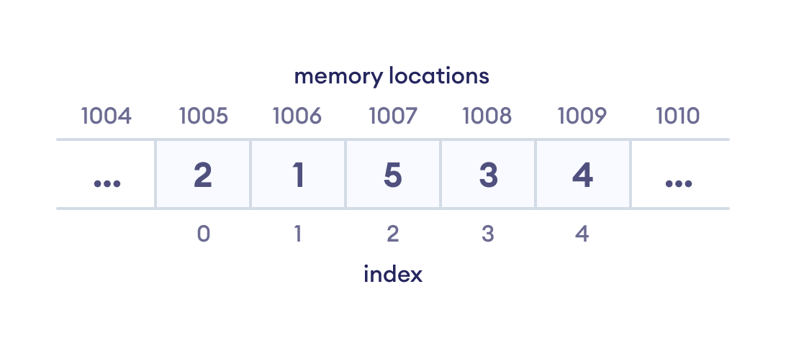Array data Structure Representation
Note: Data structure and data types are slightly different. Data structure is the collection of data types arranged in a specific order.

Types of Data Structure
Basically, data structures are divided into two categories:
- Linear data structure
- Non-linear data structure
Let's learn about each type in detail.

Linear data structures
In linear data structures, the elements are arranged in sequence one after the other. Since elements are arranged in particular order, they are easy to implement.
However, when the complexity of the program increases, the linear data structures might not be the best choice because of operational complexities.
Popular linear data structures are:

1. Array Data Structure
In an array, elements in memory are arranged in continuous memory. All the elements of an array are of the same type. And, the type of elements that can be stored in the form of arrays is determined by the programming language.
To learn more, visit Java Array.
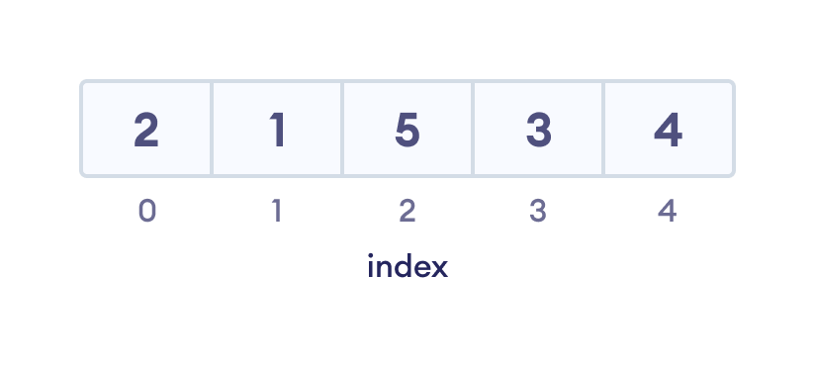An array with each element represented by an index

2. Stack Data Structure
In stack data structure, elements are stored in the LIFO principle. That is, the last element stored in a stack will be removed first.
It works just like a pile of plates where the last plate kept on the pile will be removed first. To learn more, visit Stack Data Structure.
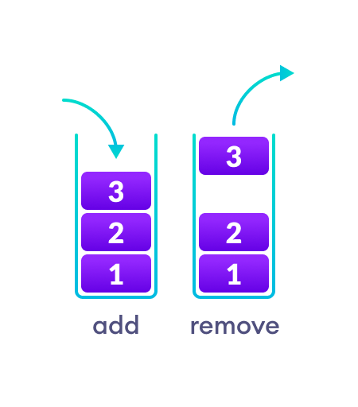In a stack, operations can be perform only from one end (top here).

3. Queue Data Structure
Unlike stack, the queue data structure works in the FIFO principle where first element stored in the queue will be removed first.
It works just like a queue of people in the ticket counter where first person on the queue will get the ticket first. To learn more, visit Queue Data Structure.
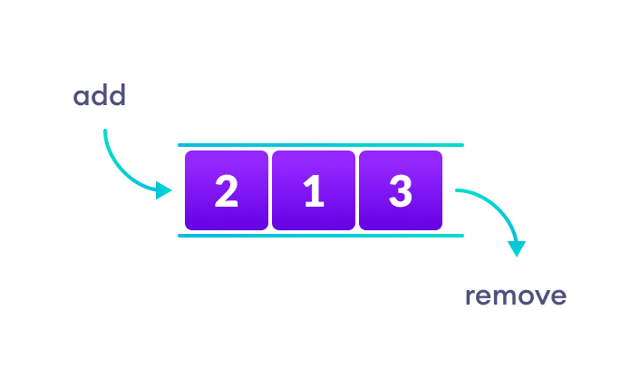In a queue, addition and removal are performed from separate ends.

4. Linked List Data Structure
In linked list data structure, data elements are connected through a series of nodes. And, each node contains the data items and address to the next node.
To learn more, visit Linked List Data Structure.
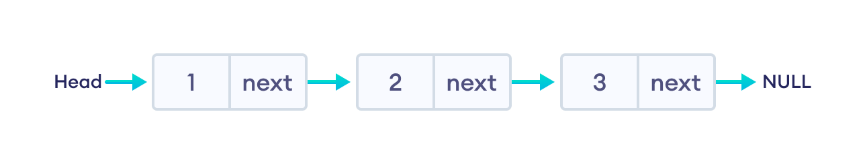
A linked list

Non linear data structures
Unlike linear data structures, elements in non-linear data structures are not in any sequence. Instead they are arranged in a hierarchical manner where one element will be connected to one or more elements.
Non-linear data structures are further divided into graph and tree based data structures.

1. Graph Data Structure
In graph data structure, each node is called vertex and each vertex is connected to other vertices through edges.
To learn more, visit Graph Data Structure.
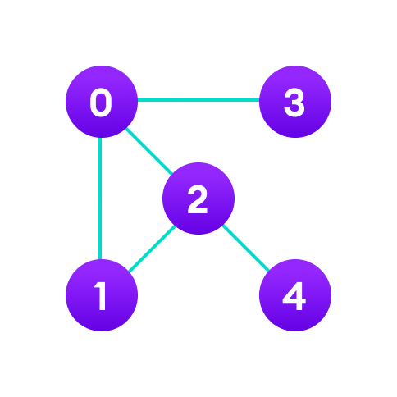Graph data structure example
Popular Graph Based Data Structures:
- Spanning Tree and Minimum Spanning Tree
- Strongly Connected Components
- Adjacency Matrix
- Adjacency List

2. Trees Data Structure
Similar to a graph, a tree is also a collection of vertices and edges. However, in tree data structure, there can only be one edge between two vertices.
To learn more, visit Tree Data Structure.
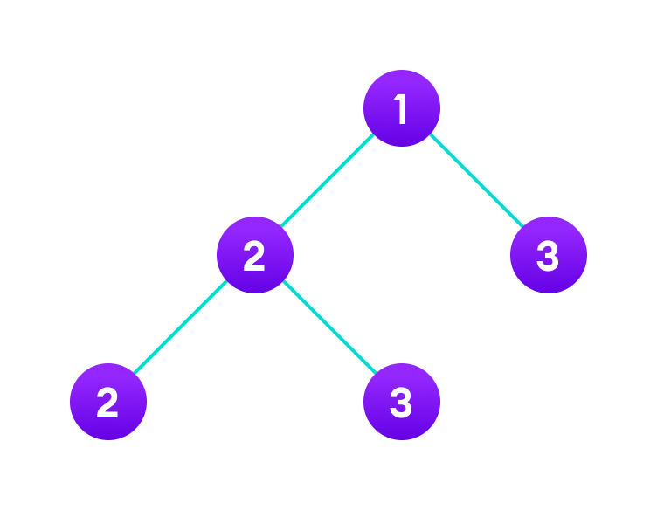Tree data structure example
Popular Tree based Data Structure
- Binary Tree
- Binary Search Tree
- AVL Tree
- B-Tree
- B+ Tree
- Red-Black Tree

Linear Vs Non-linear Data Structures
Now that we know about linear and non-linear data structures, let's see the major differences between them.
Linear Data Structures | Non Linear Data Structures
The data items are arranged in sequential order, one after the other. | The data items are arranged in non-sequential order (hierarchical manner).
All the items are present on the single layer. | The data items are present at different layers.
It can be traversed on a single run. That is, if we start from the first element, we can traverse all the elements sequentially in a single pass. | It requires multiple runs. That is, if we start from the first element it might not be possible to traverse all the elements in a single pass.
The memory utilization is not efficient. | Different structures utilize memory in different efficient ways depending on the need.
The time complexity increase with the data size. | Time complexity remains the same.
Example: Arrays, Stack, Queue | Example: Tree, Graph, Map

Why Learn Data Structures and Algorithms?
This article is for those who have just started learning algorithms and wondered how impactful it will be to boost their career/programming skills. It is also for those who wonder why big companies like Google, Facebook, and Amazon hire programmers who are exceptionally good at optimizing Algorithms.

What are Algorithms?
Informally, an algorithm is nothing but a mention of steps to solve a problem. They are essentially a solution.
For example, an algorithm to solve the problem of factorials might look something like this:
Problem: Find the factorial of n
Initialize fact = 1
For every value v in range 1 to n:
Multiply the fact by v
fact contains the factorial of n
Here, the algorithm is written in English. If it was written in a programming language, we would call it to code instead. Here is a code for finding the factorial of a number in C++.
int factorial(int n) {
int fact = 1;
for (int v = 1; v <= n; v++) {
fact = fact * v;
}
return fact;
}

Programming is all about data structures and algorithms. Data structures are used to hold data while algorithms are used to solve the problem using that data.
Data structures and algorithms (DSA) goes through solutions to standard problems in detail and gives you an insight into how efficient it is to use each one of them. It also teaches you the science of evaluating the efficiency of an algorithm. This enables you to choose the best of various choices.

Use of Data Structures and Algorithms to Make Your Code Scalable
Time is precious.
Suppose, Alice and Bob are trying to solve a simple problem of finding the sum of the first 10¹¹ natural numbers. While Bob was writing the algorithm, Alice implemented it proving that it is as simple as criticizing Donald Trump.
Algorithm (by Bob)
Initialize sum = 0
for every natural number n in range 1 to 10¹¹(inclusive):
add n to sum
sum is your answer
Code (by Alice)
int findSum() {
int sum = 0;
for (int v = 1; v <= 100000000000; v++) {
sum += v;
}
return sum;
}
Alice and Bob are feeling euphoric of themselves that they could build something of their own in almost no time. Let's sneak into their workspace and listen to their conversation.
Alice: Let's run this code and find out the sum.
Bob: I ran this code a few minutes back but it's still not showing the output. What's wrong with it?
Oops, something went wrong! A computer is the most deterministic machine. Going back and trying to run it again won't help. So let's analyze what's wrong with this simple code.
Two of the most valuable resources for a computer program are time and memory.
The time taken by the computer to run code is:
Time to run code = number of instructions * time to execute each instruction
The number of instructions depends on the code you used, and the time taken to execute each code depends on your machine and compiler.
In this case, the total number of instructions executed (let's say x) are x = 1 + (10¹¹ + 1) + (10¹¹) + 1, which is x = 2 * 10¹¹ + 3
Let us assume that a computer can execute y = 10⁸ instructions in one second (it can vary subject to machine configuration). The time taken to run above code is
Time to run y instructions = 1 second
Time to run 1 instruction = 1 / y seconds
Time to run x instructions = x * (1/y) seconds = x / y seconds
Hence,
Time to run the code = x / y
= (2 * 10¹¹ + 3) / 10⁸ (greater than 33 minutes)
Is it possible to optimize the algorithm so that Alice and Bob do not have to wait for 33 minutes every time they run this code?
I am sure that you already guessed the right method. The sum of first N natural numbers is given by the formula:
Sum = N * (N + 1) / 2
Converting it into code will look something like this:
int sum(int N) {
return N * (N + 1) / 2;
}
This code executes in just one instruction and gets the task done no matter what the value is. Let it be greater than the total number of atoms in the universe. It will find the result in no time.
The time taken to solve the problem, in this case, is 1/y (which is 10 nanoseconds). By the way, the fusion reaction of a hydrogen bomb takes 40-50 ns, which means your program will complete successfully even if someone throws a hydrogen bomb on your computer at the same time you ran your code. :)
Note: Computers take a few instructions (not 1) to compute multiplication and division. I have said 1 just for the sake of simplicity.

More on Scalability
Scalability is scale plus ability, which means the quality of an algorithm/system to handle the problem of larger size.
Consider the problem of setting up a classroom of 50 students. One of the simplest solutions is to book a room, get a blackboard, a few chalks, and the problem is solved.
But what if the size of the problem increases? What if the number of students increased to 200?
The solution still holds but it needs more resources. In this case, you will probably need a much larger room (probably a theater), a projector screen and a digital pen.
What if the number of students increased to 1000?
The solution fails or uses a lot of resources when the size of the problem increases. This means, your solution wasn't scalable.
What is a scalable solution then?
Consider a site like Khanacademy, millions of students can see videos, read answers at the same time and no more resources are required. So, the solution can solve the problems of larger size under resource crunch.
If you see our first solution to find the sum of first N natural numbers, it wasn't scalable. It's because it required linear growth in time with the linear growth in the size of the problem. Such algorithms are also known as linearly scalable algorithms.
Our second solution was very scalable and didn't require the use of any more time to solve a problem of larger size. These are known as constant-time algorithms.

Memory is expensive
Memory is not always available in abundance. While dealing with code/system which requires you to store or produce a lot of data, it is critical for your algorithm to save the usage of memory wherever possible. For example: While storing data about people, you can save memory by storing only their date of birth, not their age. You can always calculate it on the fly using their date of birth and current date.

Examples of an Algorithm's Efficiency
Here are some examples of what learning algorithms and data structures enable you to do:

Example 1: Age Group Problem
Problems like finding the people of a certain age group can easily be solved with a little modified version of the binary search algorithm (assuming that the data is sorted).
The naive algorithm which goes through all the persons one by one, and checks if it falls in the given age group is linearly scalable. Whereas, binary search claims itself to be a logarithmically scalable algorithm. This means that if the size of the problem is squared, the time taken to solve it is only doubled.
Suppose, it takes 1 second to find all the people at a certain age for a group of 1000. Then for a group of 1 million people,
- the binary search algorithm will take only 2 seconds to solve the problem
- the naive algorithm might take 1 million seconds, which is around 12 days
The same binary search algorithm is used to find the square root of a number.

Example 2: Rubik's Cube Problem
Imagine you are writing a program to find the solution of a Rubik's cube.
This cute looking puzzle has annoyingly 43,252,003,274,489,856,000 positions, and these are just positions! Imagine the number of paths one can take to reach the wrong positions.
Fortunately, the way to solve this problem can be represented by the graph data structure. There is a graph algorithm known as Dijkstra's algorithm which allows you to solve this problem in linear time. Yes, you heard it right. It means that it allows you to reach the solved position in a minimum number of states.

Example 3: DNA Problem
DNA is a molecule that carries genetic information. They are made up of smaller units which are represented by Roman characters A, C, T, and G.
Imagine yourself working in the field of bioinformatics. You are assigned the work of finding out the occurrence of a particular pattern in a DNA strand.
It is a famous problem in computer science academia. And, the simplest algorithm takes the time proportional to
(number of character in DNA strand) * (number of characters in pattern)
A typical DNA strand has millions of such units. Eh! worry not. KMP algorithm can get this done in time which is proportional to
(number of character in DNA strand) + (number of characters in pattern)
The * operator replaced by + makes a lot of change.
Considering that the pattern was of 100 characters, your algorithm is now 100 times faster. If your pattern was of 1000 characters, the KMP algorithm would be almost 1000 times faster. That is, if you were able to find the occurrence of pattern in 1 second, it will now take you just 1 ms. We can also put this in another way. Instead of matching 1 strand, you can match 1000 strands of similar length at the same time.
And there are infinite such stories...

Final Words
Generally, software development involves learning new technologies on a daily basis. You get to learn most of these technologies while using them in one of your projects. However, it is not the case with algorithms.
If you don't know algorithms well, you won't be able to identify if you can optimize the code you are writing right now. You are expected to know them in advance and apply them wherever possible and critical.
We specifically talked about the scalability of algorithms. A software system consists of many such algorithms. Optimizing any one of them leads to a better system.
However, it's important to note that this is not the only way to make a system scalable. For example, a technique known as distributed computing allows independent parts of a program to run to multiple machines together making it even more scalable.

Asymptotic Analysis: Big-O Notation and More
The efficiency of an algorithm depends on the amount of time, storage and other resources required to execute the algorithm. The efficiency is measured with the help of asymptotic notations.
An algorithm may not have the same performance for different types of inputs. With the increase in the input size, the performance will change.
The study of change in performance of the algorithm with the change in the order of the input size is defined as asymptotic analysis.

Asymptotic Notations

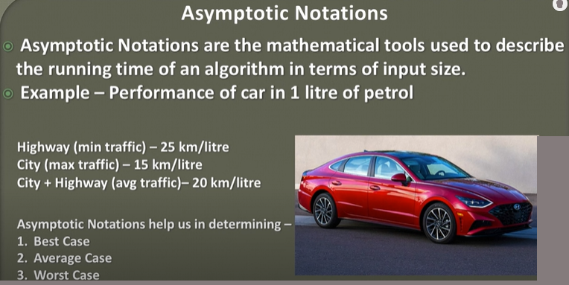
Asymptotic notations are the mathematical notations used to describe the running time of an algorithm when the input tends towards a particular value or a limiting value.
For example: In bubble sort, when the input array is already sorted, the time taken by the algorithm is linear i.e. the best case.
But, when the input array is in reverse condition, the algorithm takes the maximum time (quadratic) to sort the elements i.e. the worst case.
When the input array is neither sorted nor in reverse order, then it takes average time. These durations are denoted using asymptotic notations.
There are mainly three asymptotic notations:
- Big-O notation
- Omega notation
- Theta notation

Big-O Notation (O-notation)

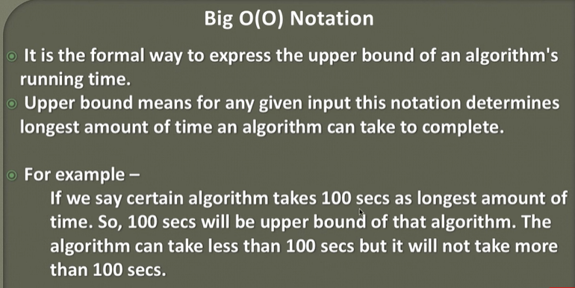
Big-O notation represents the upper bound of the running time of an algorithm. Thus, it gives the worst-case complexity of an algorithm.
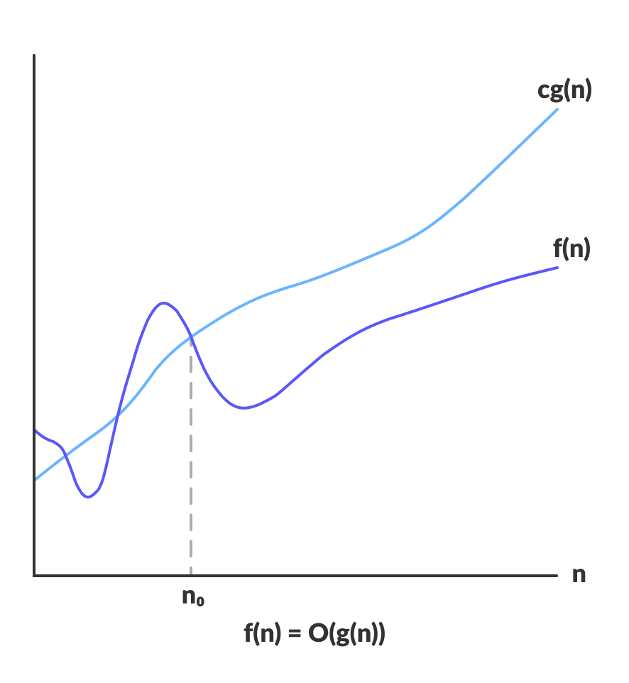
Big-O gives the upper bound of a function
O(g(n)) = { f(n): there exist positive constants c and n₀
such that 0 ≤ f(n) ≤ cg(n) for all n ≥ n₀ }
The above expression can be described as a function f(n) belongs to the set O(g(n)) if there exists a positive constant c such that it lies between 0 and cg(n), for sufficiently large n.
For any value of n, the running time of an algorithm does not cross the time provided by O(g(n)).
Since it gives the worst-case running time of an algorithm, it is widely used to analyze an algorithm as we are always interested in the worst-case scenario.

Omega Notation (Ω-notation)
Omega notation represents the lower bound of the running time of an algorithm. Thus, it provides the best case complexity of an algorithm.
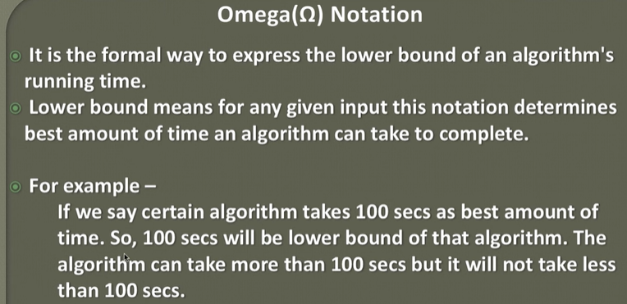
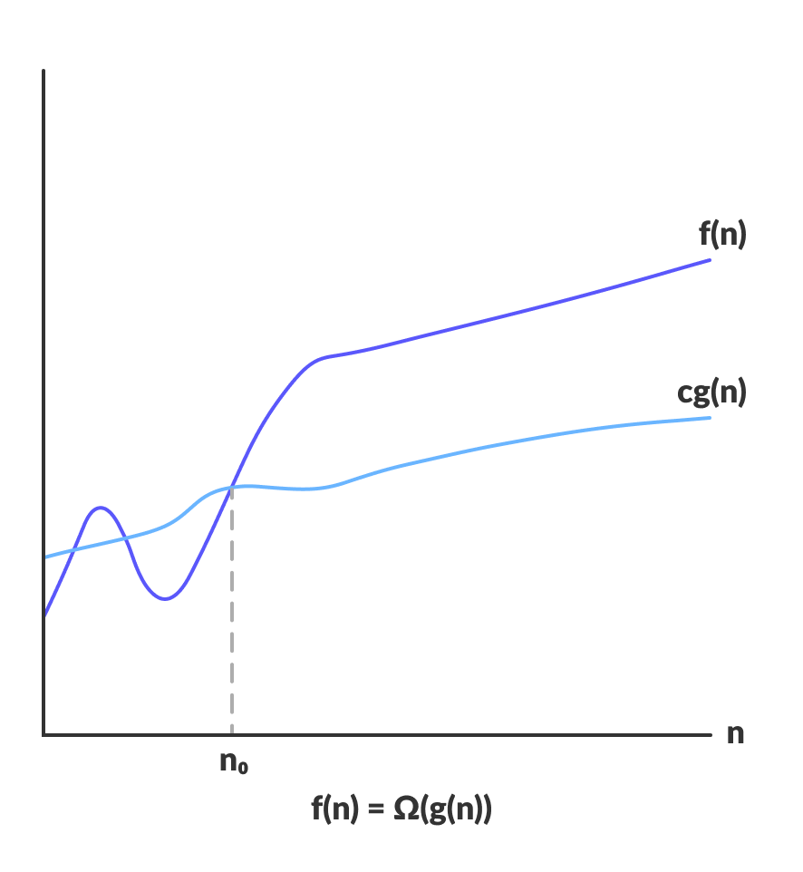Omega gives the lower bound of a function
Ω(g(n)) = { f(n): there exist positive constants c and n₀
such that 0 ≤ cg(n) ≤ f(n) for all n ≥ n₀ }
The above expression can be described as a function f(n) belongs to the set Ω(g(n)) if there exists a positive constant c such that it lies above cg(n), for sufficiently large n.
For any value of n, the minimum time required by the algorithm is given by Omega Ω(g(n)).

Theta Notation (Θ-notation)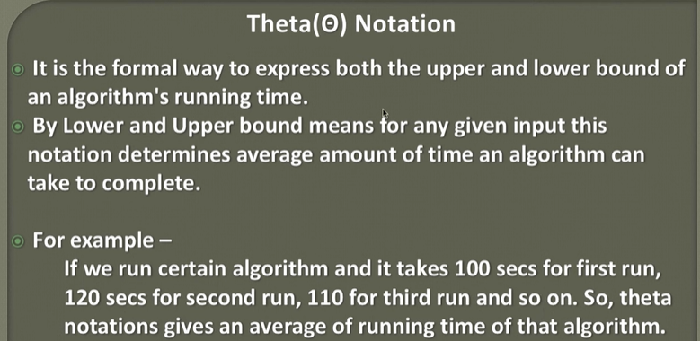
Theta notation encloses the function from above and below. Since it represents the upper and the lower bound of the running time of an algorithm, it is used for analyzing the average-case complexity of an algorithm.
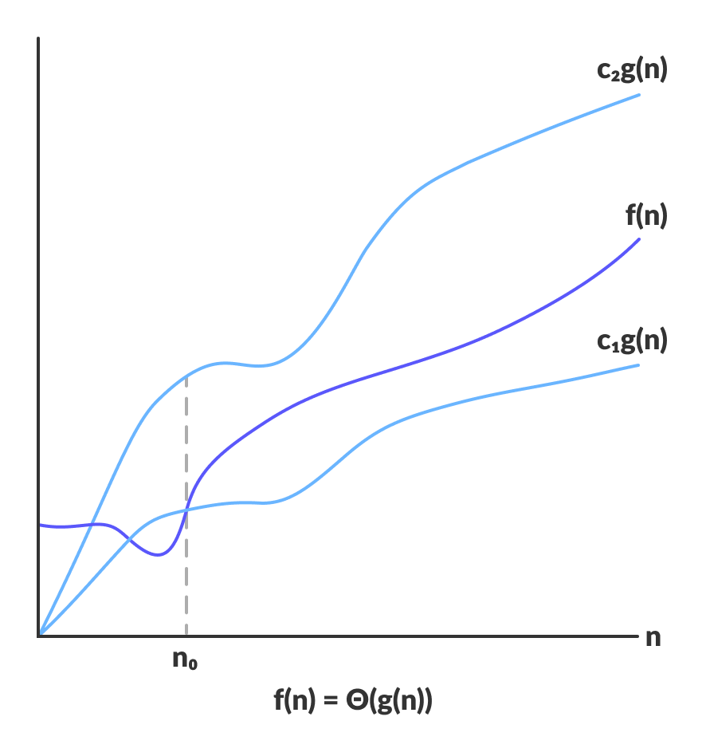Theta bounds the function within constants factors
For a function g(n), Θ(g(n)) is given by the relation:
Θ(g(n)) = { f(n): there exist positive constants c₁, c₂ and n₀
such that 0 ≤ c₁g(n) ≤ f(n) ≤ c₂g(n) for all n ≥ n₀ }
The above expression can be described as a function f(n) belongs to the set Θ(g(n)) if there exist positive constants c₁ and c₂ such that it can be sandwiched between c₁g(n) and c₂g(n), for sufficiently large n.
If a function f(n) lies anywhere in between c₁g(n) and c₂g(n) for all n ≥ n0, then f(n) is said to be asymptotically tight bound.
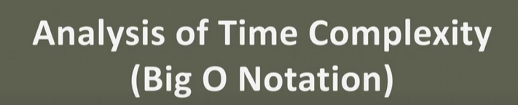
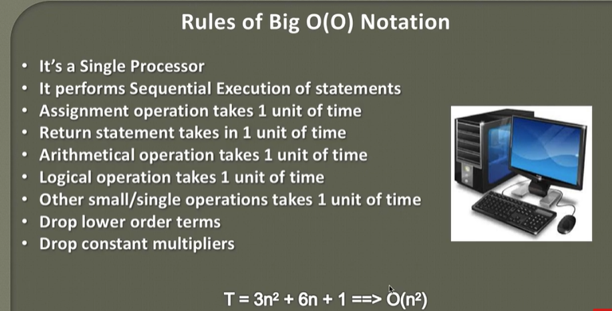

Calculating Time Complexity of Constant Algorithm
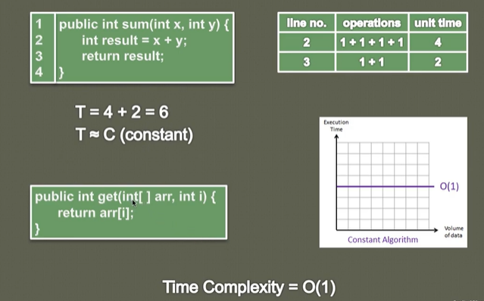

Calculating Time Complexity of Linear Algorithm

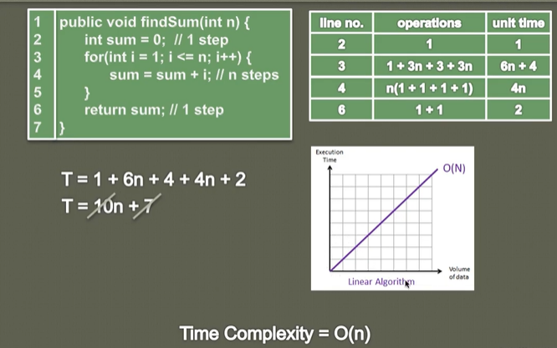
Calculating Time Complexity of Polynomial Algorithm

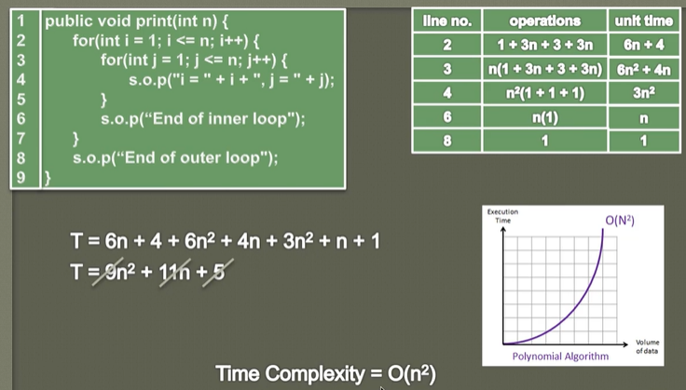

Abstract Data Types
we will learn about ADT but before understanding what ADT is let us consider different in-built data types that are provided to us. Data types such as int, float, double, long, etc. are considered to be in-built data types and we can perform basic operations with them such as addition, subtraction, division, multiplication, etc. Now there might be a situation when we need operations for our user-defined data type which have to be defined. These operations can be defined only as and when we require them. So, in order to simplify the process of solving problems, we can create data structures along with their operations, and such data structures that are not in-built are known as Abstract Data Type (ADT).

Abstract Data type (ADT) is a type (or class) for objects whose behavior is defined by a set of values and a set of operations. The definition of ADT only mentions what operations are to be performed but not how these operations will be implemented. It does not specify how data will be organized in memory and what algorithms will be used for implementing the operations. It is called “abstract” because it gives an implementation-independent view.
The process of providing only the essentials and hiding the details is known as abstraction.
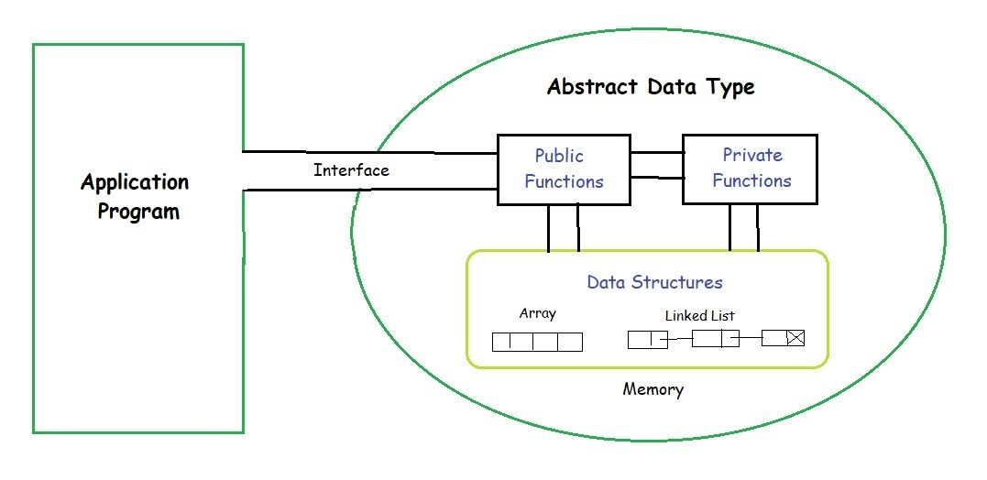
The user of data type does not need to know how that data type is implemented, for example, we have been using Primitive values like int, float, char data types only with the knowledge that these data type can operate and be performed on without any idea of how they are implemented.
So a user only needs to know what a data type can do, but not how it will be implemented. Think of ADT as a black box which hides the inner structure and design of the data type. Now we’ll define three ADTs namely List ADT, Stack ADT, Queue ADT.

List ADT
The data is generally stored in key sequence in a list which has a head structure consisting of count, pointers and address of compare function needed to compare the data in the list.
The data node contains the pointer to a data structure and a self-referential pointer which points to the next node in the list.
The List ADT Functions is given below:
get() – Return an element from the list at any given position.
insert() – Insert an element at any position of the list.
remove() – Remove the first occurrence of any element from a non-empty list.
removeAt() – Remove the element at a specified location from a non-empty list.
replace() – Replace an element at any position by another element.
size() – Return the number of elements in the list.
isEmpty() – Return true if the list is empty, otherwise return false.
isFull() – Return true if the list is full, otherwise return false.

Stack ADT
In Stack ADT Implementation instead of data being stored in each node, the pointer to data is stored.
The program allocates memory for the data and address is passed to the stack ADT.
The head node and the data nodes are encapsulated in the ADT. The calling function can only see the pointer to the stack.
The stack head structure also contains a pointer to top and count of number of entries currently in stack.
push() – Insert an element at one end of the stack called top.
pop() – Remove and return the element at the top of the stack, if it is not empty.
peek() – Return the element at the top of the stack without removing it, if the stack is not empty.
size() – Return the number of elements in the stack.
isEmpty() – Return true if the stack is empty, otherwise return false.
isFull() – Return true if the stack is full, otherwise return false.

Queue ADT
The queue abstract data type (ADT) follows the basic design of the stack abstract data type.
Each node contains a void pointer to the data and the link pointer to the next element in the queue. The program’s responsibility is to allocate memory for storing the data.
enqueue() – Insert an element at the end of the queue.
dequeue() – Remove and return the first element of the queue, if the queue is not empty.
peek() – Return the element of the queue without removing it, if the queue is not empty.
size() – Return the number of elements in the queue.
isEmpty() – Return true if the queue is empty, otherwise return false.
isFull() – Return true if the queue is full, otherwise return false.
Features of ADT:
Abstraction: The user does not need to know the implementation of the data structure only essentials are provided.
Better Conceptualization: ADT gives us a better conceptualization of the real world.
Robust: The program is robust and has the ability to catch errors.

